# 4th Testing – 26th of April

Story 20: Log Out

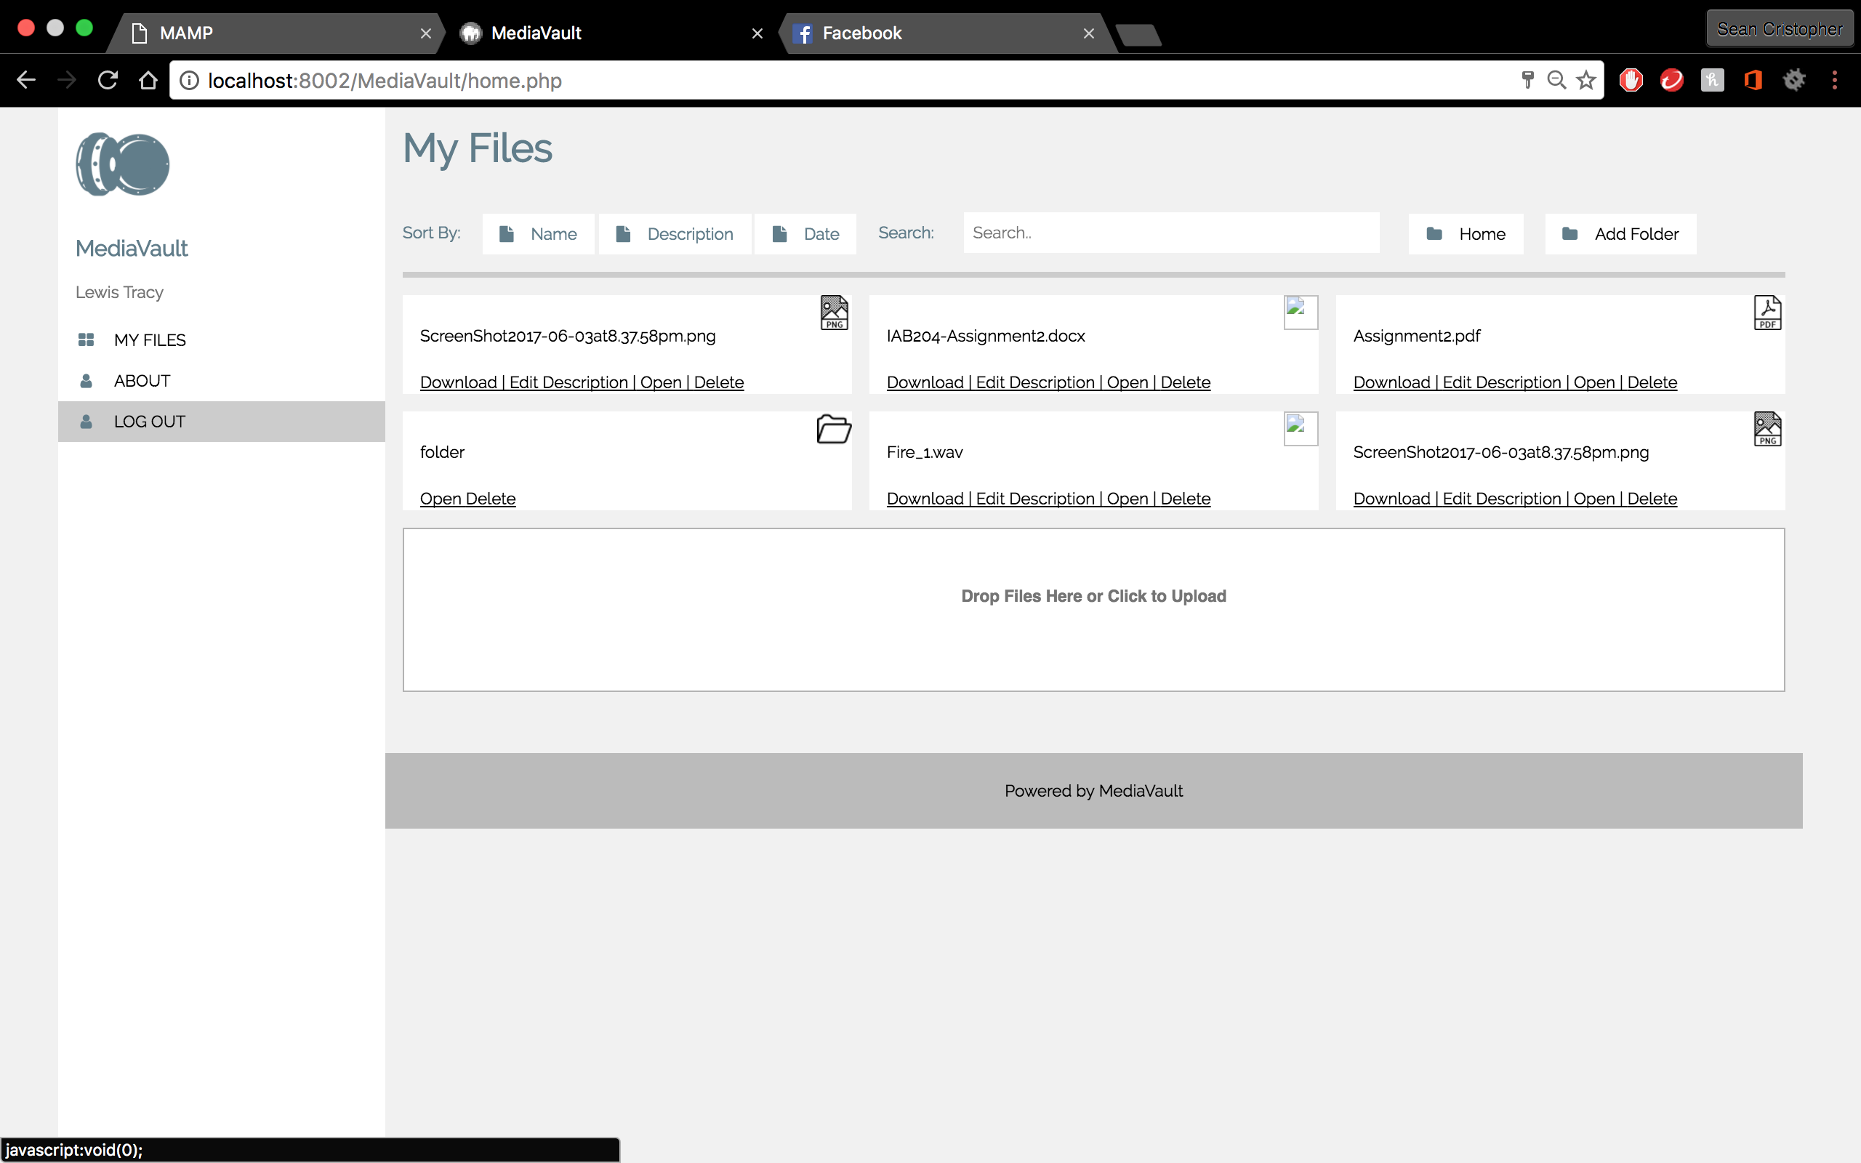

* Button is created for log out
* Tests shows logging out feature functions

Story 7: Add Folder

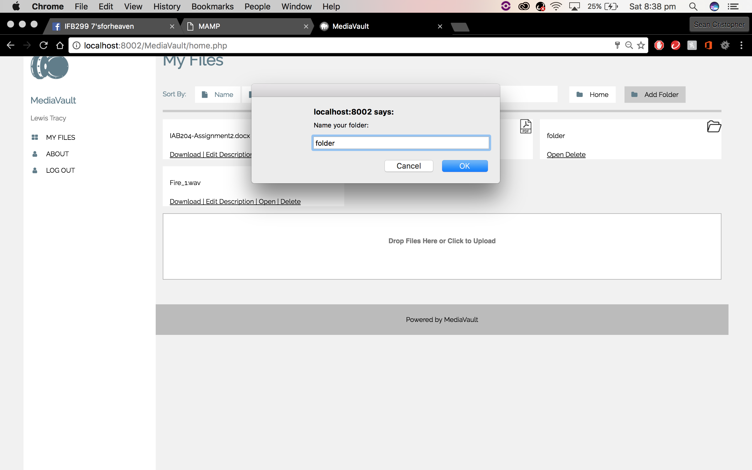 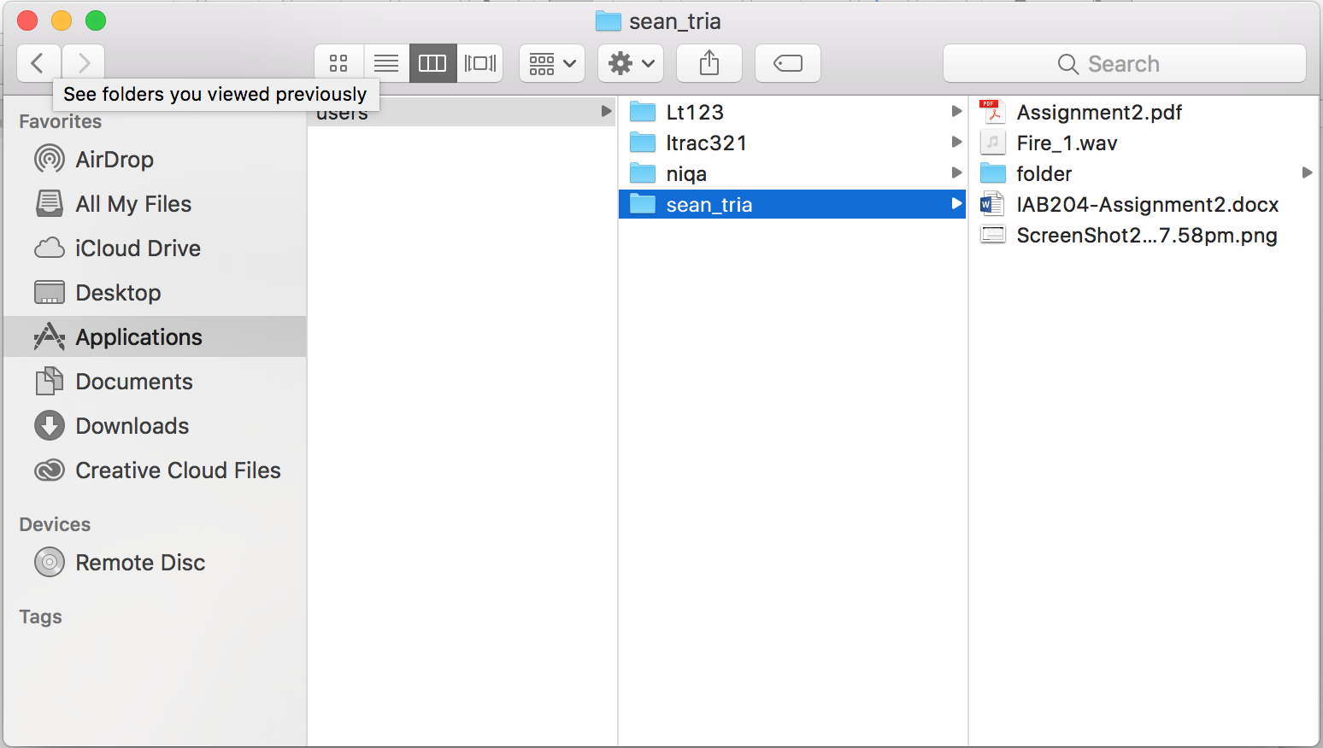

* Button for adding folder is scripted
* Folder created is saved on the file server
* Folder created is added to the grid
* Manual refresh of page is required to view created folder

Story 11: Delete File

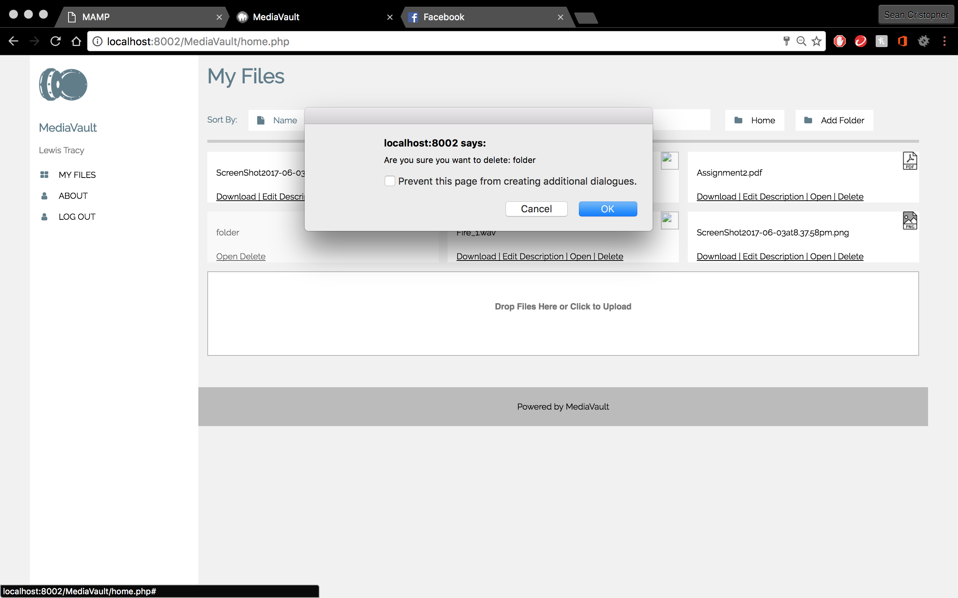

* Delete button is independent for each file/folder
* Pop-up message for user’s final decision on deleting file/folder/s
* File/folder deletes if user confirms
* The grid refreshes when deleted to upload the grid

Summary: Testing completed. User story functions. Only issue, is when adding folder, manual refresh of the page is required to view the folder created. Log out takes time to initialise log out.